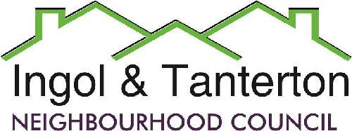
Gill Flynn - Clerk and RFO
Email: clerk@ingoltantertonnc.org.uk

Agenda

All Neighbourhood Councillors are hereby summoned to the meeting of
Ingol and Tanterton Neighbourhood Council on Tuesday 28th April 2026 at 7pm
at Tanterton Village Centre.

1.To receive apologies.

2.To receive declarations of interest.

3.To approve the minutes of the meeting held on Wednesday 1st April 2026.

4.Public participation.

5.To consider planning applications, reports and matters.
06/2026/0248 Approval of amended plans.
4, Oaktree Close, Preston, PR2 3UZ
Amendment to planning permission 06/2025/1054 comprising alterations to first floor rear roof from hip to dual pitched (non-material amendment not subject to consultation.m

06/2026/0261 Approval of amended plans
Dovedale Court Residential Home, Dovedale Avenue, Preston, PR2 Amendment to planning permission 06/2016/0237 comprising re-tiling/cladding to elevations (non-material amendment not subject to consultation.

06/2026/0336
334, Tag Lane, Preston, PR2 3UY
Description: Single storey rear extension following demolition of existing outbuilding.

06/2026/0355
Lawful use certificate
Address: 1, Cottam Nurseries, Cottam Lane, Preston, PR2 3XW
Description: Certificate of Lawfulness for a single storey side extension and cladding to existing side elevation.

6.Finance.
Expenditure
BACS | MB Landscaping | Lengthsman basic plus 20 hours | £984.00
BACS | Gill Flynn – clerk | Monthly expenses | £31.13
DD | British Gas | Cottam Gate electrics | £34.92
DD | EasyWebsites | Domain, hosting and emails | £56.76
BACS | HMRC | PAYE / NI/ Employment contributions | £276.03
BACS | Nurture | Monthly grass cutting schedule | £509.20
BACS | Intact | Grant #1 2026/2027 | £15,000.00
BACS | TVC | Grant #1 2026/2027 | £15,000.00
BACS | Preston City Council | Christmas tree and lights installation | £2387.88
BACS | Gill Flynn | Reimbursement for the Scarecrow competition print | £139.39
BACS | Scarecrow competition | Prize money | £190.00
BACS | Glasdon | Ingol Dip bin | £277.13
Receipts
BACS | Preston City Council | CiL Ingol Golf Club | £9087.45
BACS | Preston City Council | Greenspace refund | £4775.00

7.To consider and approve the completed AGAR and receive the internal auditors report.

8.To consider the update on the Scarecrow competition.

9.Reports and correspondence (information only).

10.Date and time of next meetings.

Press and public are welcome to attend.

